RootTrace
Version 0.87
Available from https://sourceforge.net/projects/roottrace
This is a working document, and it will evolve: PLEASE CHECK SOURCEFORGE FOR THE LATEST VERSION OF THIS DOCUMENT.
See end of document for licence.

Requirements
RootTrace has been built and tested in Windows XP, and now ported to Vista where it should work fine. Sorry, Windows only! Tracing can take a while (e.g. a long sequence with many roots might take a few hours) – faster processors are better. I would think 1Gb+ of memory should be fine.
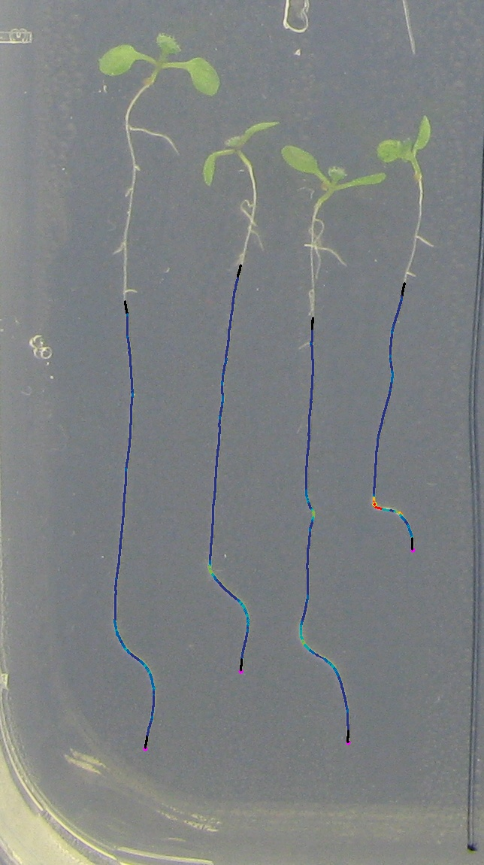

Note on use
While we believe the results to be accurate, this program is constantly being developed and improved, and it is possible it contains bugs. It is good practice to compare some results with results determined using other methods, to help ascertain the program is working as you expect. If you find or suspect a problem, please either email me, or report a bug on the SourceForge website. (https://sourceforge.net/tracker/?group_id=243086). Feature requests can be posted here too.

Getting started
Some example images have been supplied with the software for you to play with.
- Install the OpenCV libraries from https://sourceforge.net/project/showfiles.php?group_id=22870&package_id=16937 (RootTrace was developed with Version 1.0, please install exactly this version). This needs to be done with administrator privileges in order for the paths to be set up correctly. VISTA USERS: if you run into problems, please see the troubleshooting guide at the end of this document.
- Run RootTrace’s setup.exe and install the software
- Load RootTrace by locating the program in the Start menu
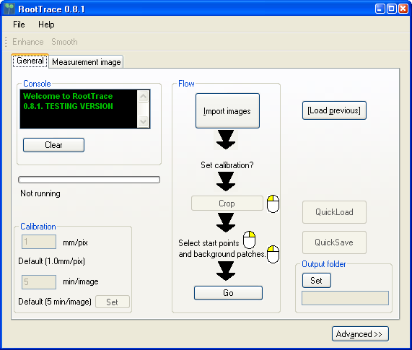

- Click Import Images
  - Navigate to the Examples folder
  - Select the 3 input images (“Capture_… .jpg” - Use shift+click and ctrl+click to help you)
  - Click open. Some windows should open up.
- Set the output directory. This is where the output files are stored. It will default to a ‘output’ subfolder if one exists, or else the folder the images are in will be used. A new folder can be created in which to store the output.
- Load the start points and background file
  - Click QuickLoad. Individual background and start point files can be saved/loaded on the Advanced dialog.
- Click Go to begin tracing
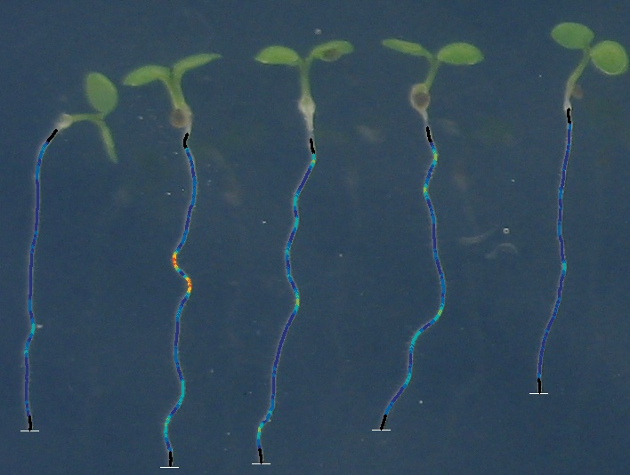
- When all three images have been traced, click on the title bar of the image to make it active, press ‘Esc’ to exit the images, and close the program using the cross in the top right. - NOTE Always exit in this order. Other methods of exiting may be unstable at the moment… To exit the software while it is still processing the images, simply close the main RootTrace window .
- Files saved:
  - Generally, output files are saved in the ‘output’ subfolder if one exists (you can create and select one in the Set dialog under ‘Output Folder’ ). Otherwise, they are saved in the same folder as the input files, or any other folder as specified.
  - Output files consist of:
    - The trace images.
These have the original filenames preceded by “_”. They show the trace made by rootrace at each timepoint. Red = large curvature angle dark blue = low curvature angle (the colours are the same as for the curvature plot). They also show the largest detected curve above a threshold, if one is found (yellow circle). The black areas on the ends of the trace indicate border areas where curvature cannot be determined (because one of the calculation points extends beyond the trace); the length of these give you an idea of the scale over which curvature is calculated (the length of lines BA and AC in Figure 3).
    - Length measurements file. This is named after the name of the first input file, with “_data.csv” tagged on the end. For each file the length of the root is presented (in pixels, or millimetres if this was entered). The order of the measurements corresponds to the order in which the start points were clicked.
    - Curvature data
      - Curvature plots, one for each root (created in the order the roots were traced), curvature_rootX.bmp. If a large curve (e.g. gravitropic response) was detected, it will be marked on this chart with grey crosshairs.
      - Gravitational response. This is presented as a preview histogram at the end of the tracings, and saved as gravHistogram.bmp; the raw data is saved as grav_response_histogram.csv. It shoes the number of roots showing a gravitational response in each time bin, calculated from the detection of the gravitropic point and root length/time data. The onset time is determined by noting the length when the angular threshold is exceeded, then looking back through the (median filtered) time-length data to determine the first time the root was recorded as being that length.
      - Each root has an associated curvature_rootN.csv file. This stores, for each file, the local angle measured at each point down the root trace. A value of 999 indicates that a curvature measurement was not possible at that location (the black trace ends in the trace images). Currently, this length is in pixels.
  - Any other files are largely for debug purposes. NOTE watch out for files being overwritten each time you run the software. It’s a good idea to back them up to another folder.
- Removing the software
  - Uninstall from the start menu, select RootTrace->Uninstall.

Manually setting start points
Right-click on the image to set start points for traces. At present it is not possible to delete start points. The user must start the software again.

Manually selecting region(s) for background statistics
A rectangular region is selected by left clicking on the image to first define one corner of a rectangle, and dragging to the opposite. The region will be drawn in white.
Two options are possible.
- One region. Select one background region as above. The pixels in this region will be used to build a background model and used for all roots.
- One region per root. Define exactly one background region per root, in the same order the trace start points where defined. The pixels in each region will be used to build a background model for each corresponding start point.

Cropping
The images in the sequence can be cropped by defining a crop on the first frame. Press the Crop button and then define a rectangle as per selecting a background above. All images will be cropped this way.

QuickSave and QuickLoad
This allow you to save a set of start points and a background for a particular working directory. Just define start points and background region(s), the hit QuickSave. To load, load the images and hit QuickLoad. More save and load options are available in the Advanced pane.

Calibration
The calibration panel allows you to set the number of millimetres per pixel and the number of minutes between images. This must be done after images have been loaded, but before the tracing has started. Don’t forget to click Set after you have entered the values to commit the changes.

Multiple sequences
It is best to restart the software between sequences for maximum reliability.

Discussion Group
There is a RootTrace discussion group at http://groups.google.com/group/roottrace-users
Sign up to share comments and to get announcements of bugs and fixes.

Problems?
Problem | Solution
The program always finishes the trace before the end of the root | 1. Do the background regions you specify contain parts of roots or image noise which looks similar in colour to roots? This will cause an early termination of the trace. Choose different background regions.  2. Lower the background prior in the advance settings.  3. Does the root bend such that it points upwards in the image? The tracker will not move “up” the image. This is to prevent back tracking. To work around this, it may be possible to rotate your images before processing them, so the root is pointing downwards.  4. If your roots simply fade out at the end, or are very thin, then there is no workaround for this. Sorry.  5. There is currently a maximum length of a root trace hardwired into the program. If you are tracing long images of roots, you may encounter this.
A message complains of a missing DLL file | 1. The software needs an external library to work correctly.  Download the OpenCV library for Windows from http://sourceforge.net/project/showfiles.php?group_id=22870 and install on your system and try again. Make sure you install version 1.0, and that you have all the necessary access rights for the install program to set up paths on your system. VISTA USERS: it seems the OpenCV installer does not set up the system path correctly in Vista. To fix this:  - Open control panel -> System -> Advanced System Settings  - Click Environment Variables…  - In the lower System Variables panel, find a variable called Path, click on it, and click Edit…  - Scroll right to the end of the text, and add in: ;C:\Program Files\OpenCV\bin  assuming you installed OpenCV in the default directory, otherwise amend the above as appropriate.  5. Click OK and close all the windows. Re-try RootTrace.  2. Email me the message if the above doesn’t fix it.
An Out Of Memory message appears | Try using fewer image files as input; if possible try using every other file. Email me with the details of the message, the number of files you were trying to open, the RAM on your computer and one example input file.
I installed RootTrace in Program Files, I’m running Vista, and the examples don’t work right | Vista is picky about what files can be written to folders in Program Files. To find your output files, navigate to the RootTrace examples folder, and click ‘Compatability Files’. You should then see them.

If you need more help, please email andrew.french@cpib.ac.uk. If relevant, it would be helpful to email me an example input image file as well.

LICENCE
Copyright (c) 2009, University of Nottingham
All rights reserved.
Redistribution and use in source and binary forms, with or without modification, are permitted provided that the following conditions are met:
Redistributions of source code must retain the above copyright notice, this list of conditions and the following disclaimer.
Redistributions in binary form must reproduce the above copyright notice, this list of conditions and the following disclaimer in the documentation and/or other materials provided with the distribution.
Neither the name of the University of Nottingham nor the names of its contributors may be used to endorse or promote products derived from this software without specific prior written permission.
THIS SOFTWARE IS PROVIDED BY THE COPYRIGHT HOLDERS AND CONTRIBUTORS "AS IS" AND ANY EXPRESS OR IMPLIED WARRANTIES, INCLUDING, BUT NOT LIMITED TO, THE IMPLIED WARRANTIES OF MERCHANTABILITY AND FITNESS FOR A PARTICULAR PURPOSE ARE DISCLAIMED. IN NO EVENT SHALL THE COPYRIGHT OWNER OR CONTRIBUTORS BE LIABLE FOR ANY DIRECT, INDIRECT, INCIDENTAL, SPECIAL, EXEMPLARY, OR CONSEQUENTIAL DAMAGES (INCLUDING, BUT NOT LIMITED TO, PROCUREMENT OF SUBSTITUTE GOODS OR SERVICES; LOSS OF USE, DATA, OR PROFITS; OR BUSINESS INTERRUPTION) HOWEVER CAUSED AND ON ANY THEORY OF LIABILITY, WHETHER IN CONTRACT, STRICT LIABILITY, OR TORT (INCLUDING NEGLIGENCE OR OTHERWISE) ARISING IN ANY WAY OUT OF THE USE OF THIS SOFTWARE, EVEN IF ADVISED OF THE POSSIBILITY OF SUCH DAMAGE.

